“BE the Church” Worksheet

What is “the Church?”

- We get the word, “church” from the original Greek word “_________________.”
- Church is always about a _________________ of believers.
- Often, in scriptures, instead of “church” we find the phrase “______________________________.”

Look up the following scriptures: (stop the video to complete this exercise)

• 1 Corinthians 12:13

• 1 Corinthians 12:27

• Romans 12:4-5

• Colossians 1:18

• Colossians 1:24

• Ephesians 4:15-16

What do you see these scriptures saying “Church” is supposed to be?

(continue video)

To “be the church” is an active and engaging __________________.

Look at the early church in the book of Acts, chapter 2, starting with verse 42.

“42They devoted themselves to the apostles' teaching and to fellowship, to the breaking of bread and to prayer. 43Everyone was filled with awe at the many wonders and signs performed by the apostles. 44All the believers were together and had everything in common. 45They sold property and possessions to give to anyone who had need. 46Every day they continued to meet together in the temple courts. They broke bread in their homes and ate together with glad and sincere hearts, 47praising God and enjoying the favor of all the people. And the LORD added to their number daily those who were being saved.”

NOTES:

Stop the video here and answer these questions:

- “How have you experienced God’s redeeming love?”

- “How have you experienced love in the church?”

- “How do you currently “be the church?”

- If you don’t currently do anything as part of “the church,” what do you envision yourself doing?

(continue video)

So, what is the church?

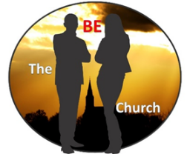
Instead of “going to church,” try “being the church.”

